HYMNS - WORSHIP SERVICE SEPTEMBER 13, 2020
THE HYMNAL 1982

OPENING HYMN Lift high the cross
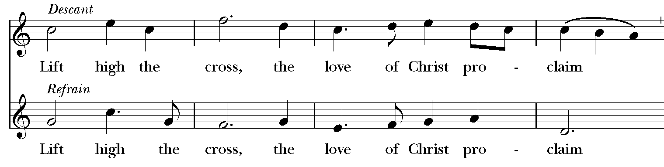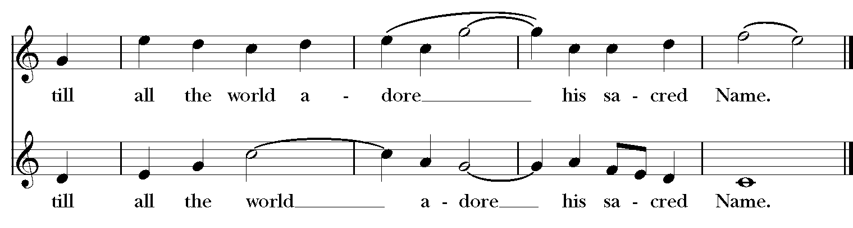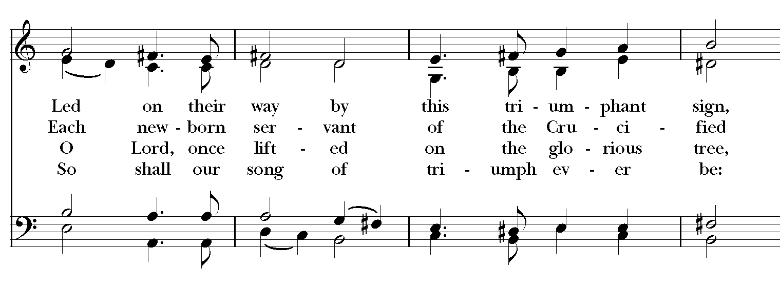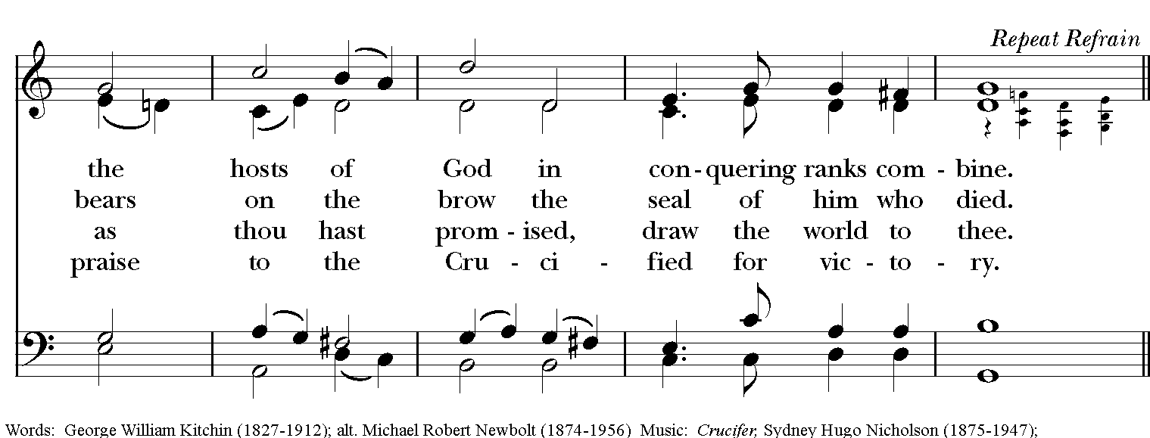
Words: George William Kitchin; alt. Michael Robert Newbolt
Music: Crucifer, Sydney Hugo Nicholson; desc. Richard Proulx.

SEQUENCE HYMN When I survey the wondrous cross
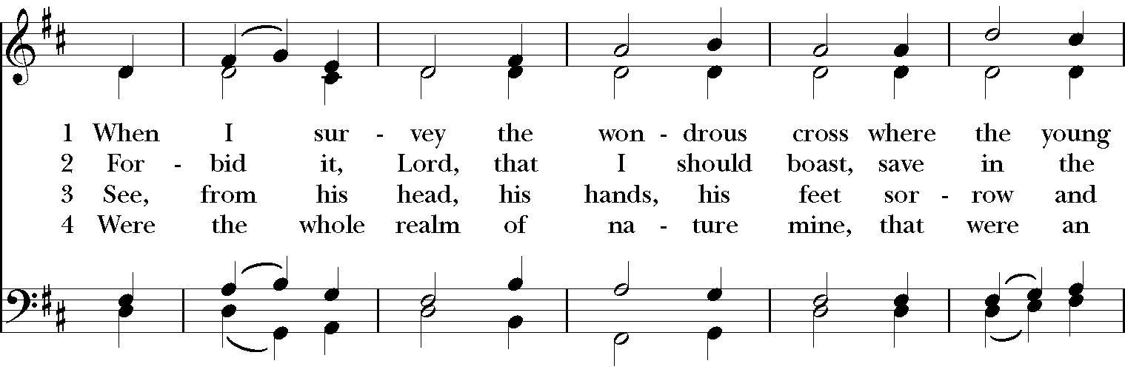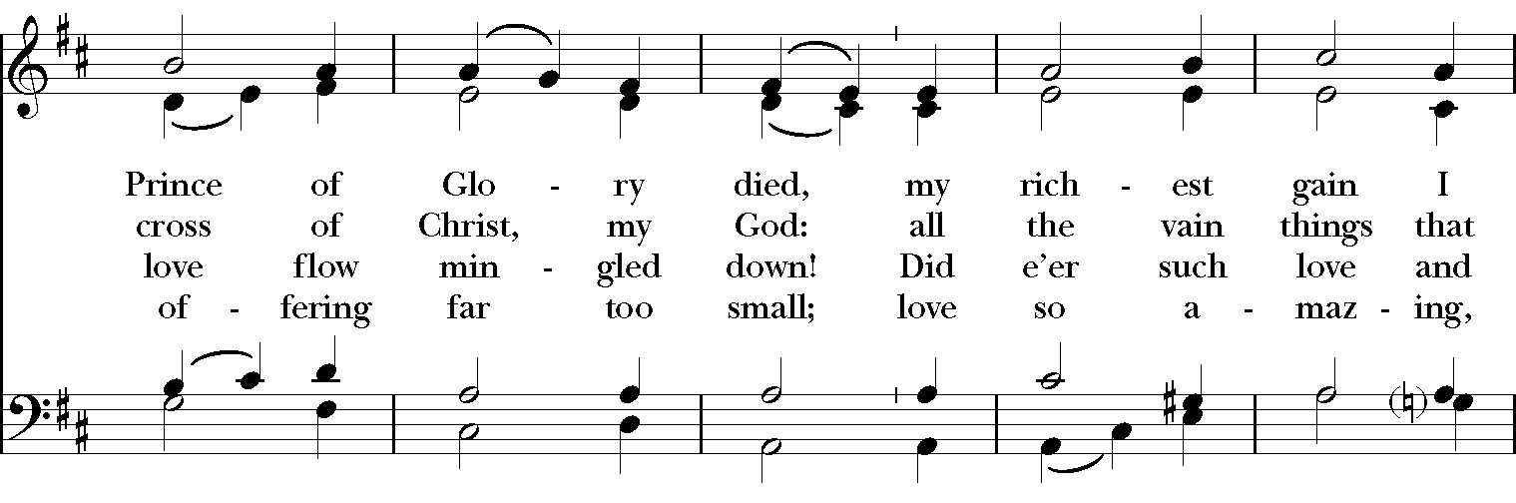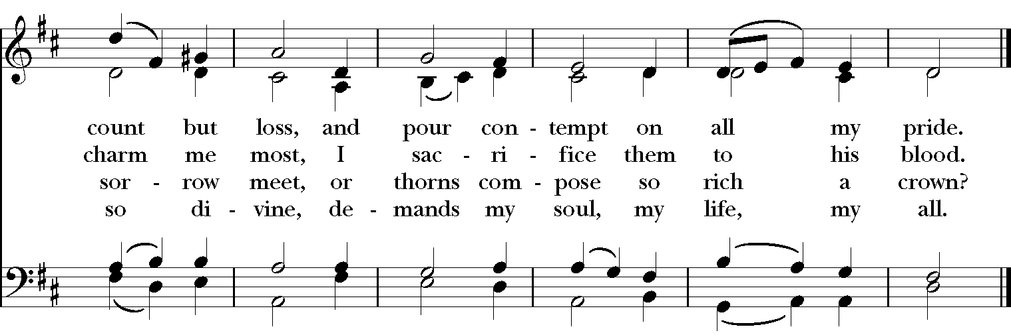
Words: Isaac Watts
Music: Rockingham, from Second Supplement to Psalmody in Miniature, ca. 1780; harm. Edward Miller.

CLOSING HYMN All hail the power of Jesus’ Name
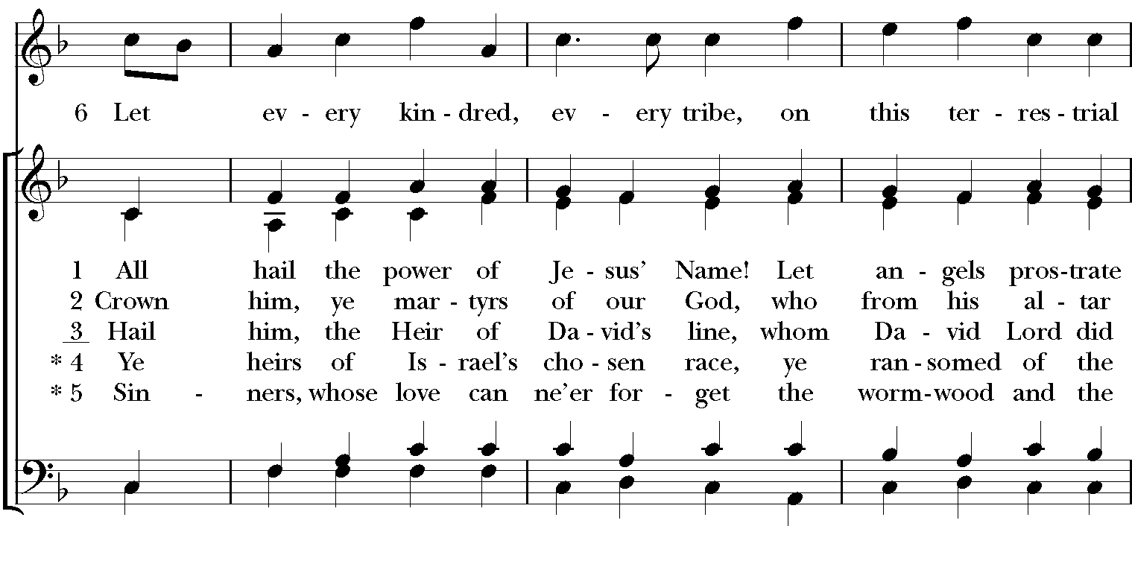
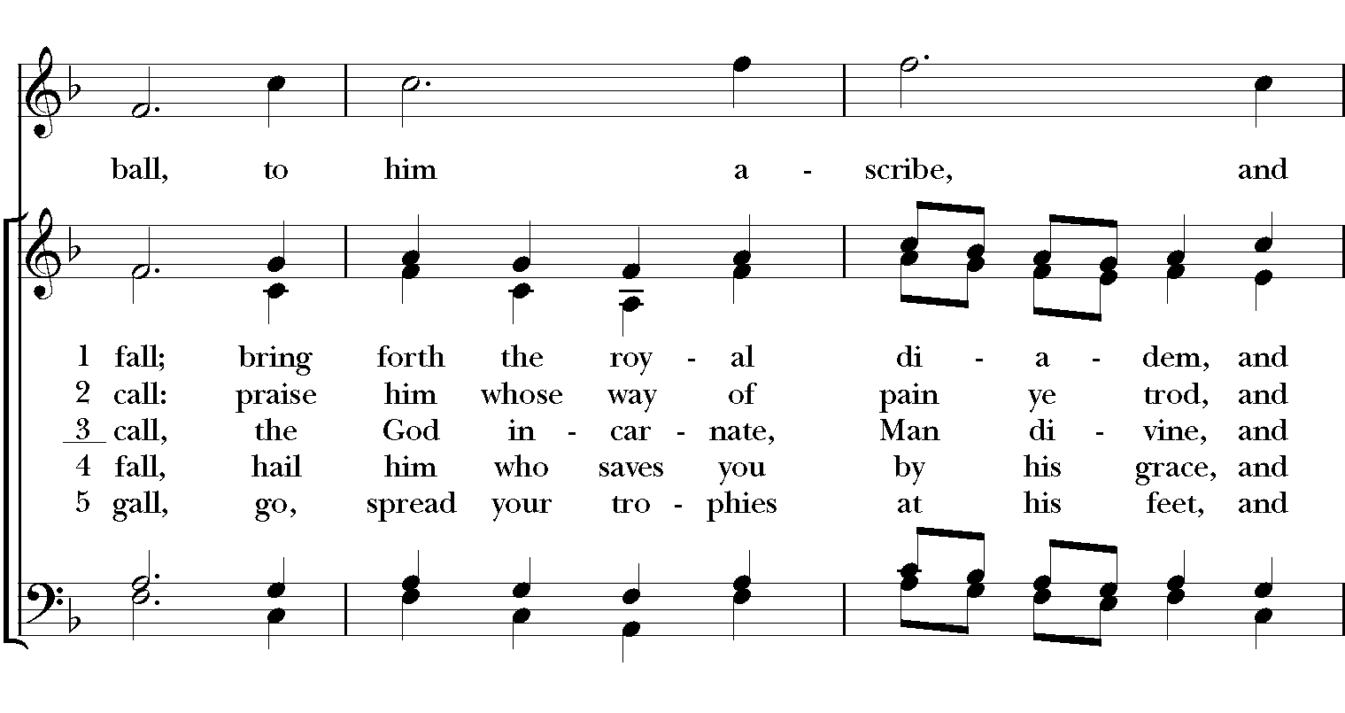
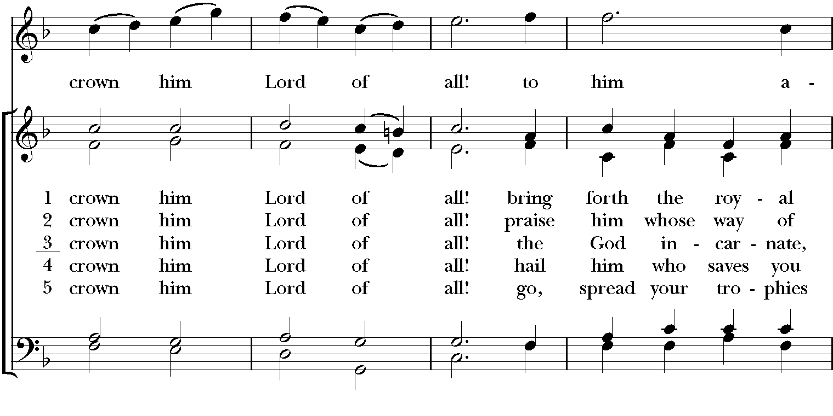
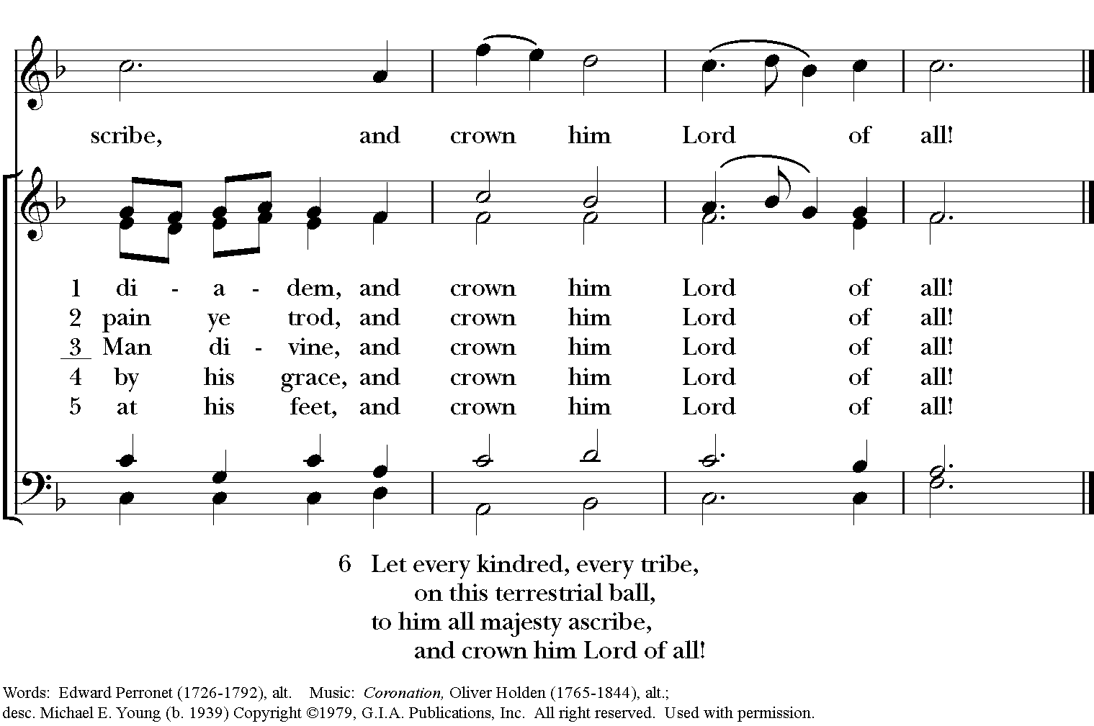
Words: Edward Perronet.
Music: Coronation, Oliver Holden, alt.; desc. Michael E. Young.

